On every page of our website, we have a mandatory interactive menu on top that allows us to go to other HTML pages as well as a dedicated area to contact us on Instagram.

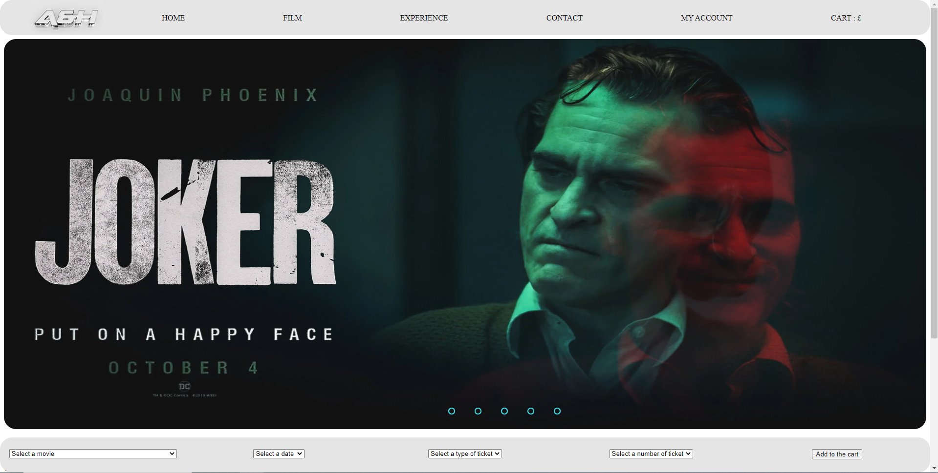

On our "Home" page, we have a film slideshow. You can click on any of the films in the slideshow to open the details. At the bottom of the page, we also have a quick access to buy film tickets.

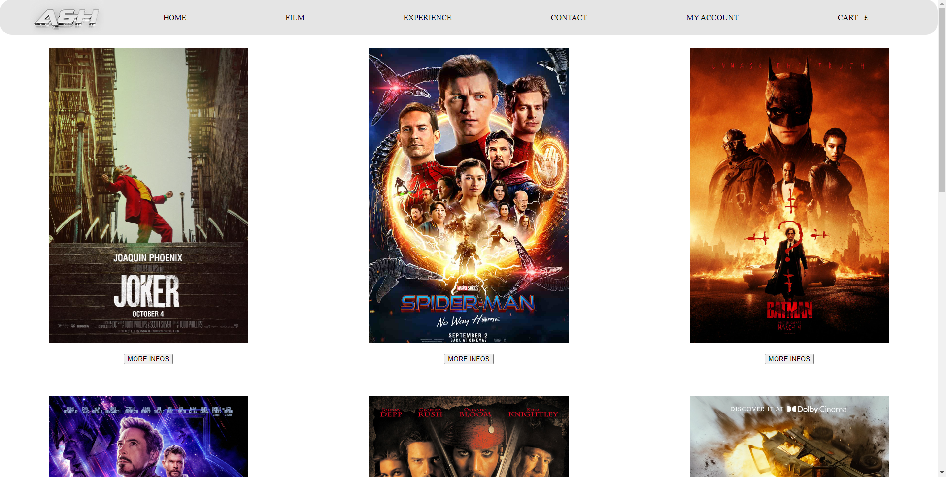

In our "Film" page, we have a list of the 9 films available in our cinema. We have the possibility to click on one of them to get its information.

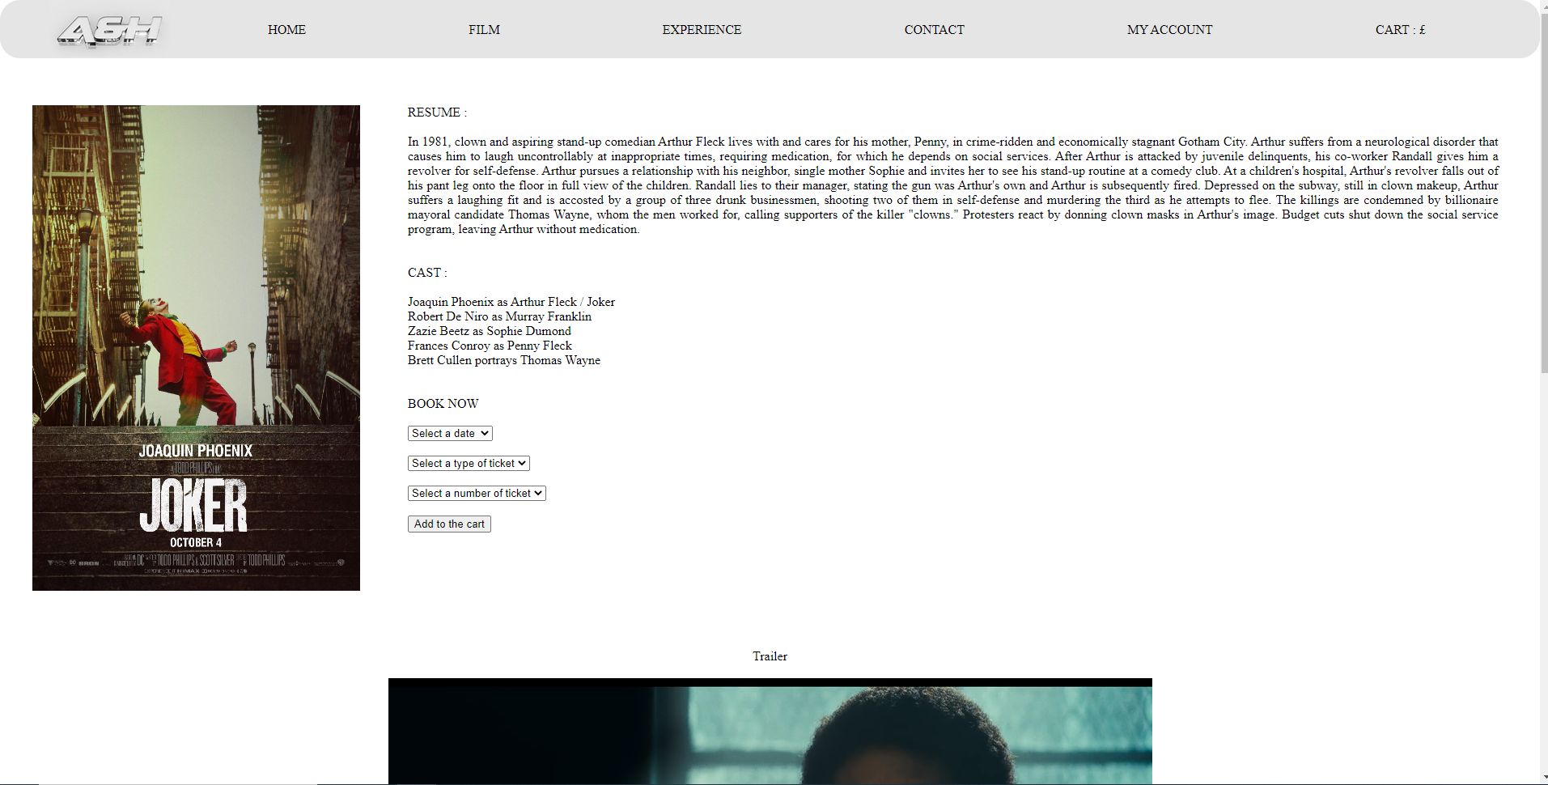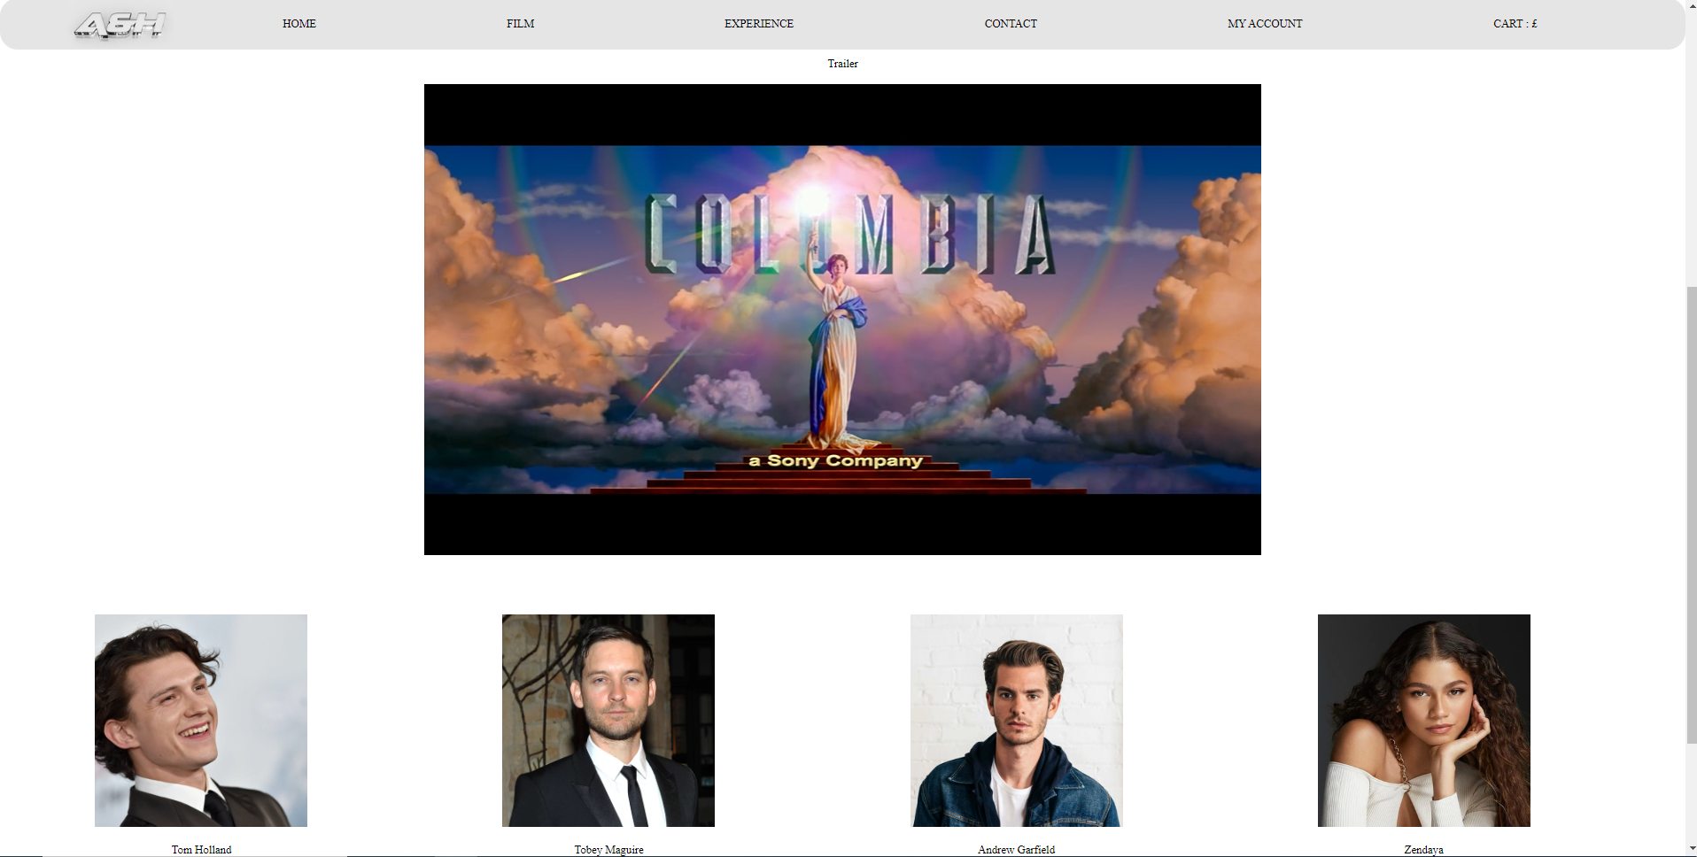

This new page gives us information such as the summary of the film, the cast, the possibility to buy tickets for the film and also to see the trailer. Also, if you want to have more information about the actors by clicking on their picture, our site links you directly to their Wikipedia pages.

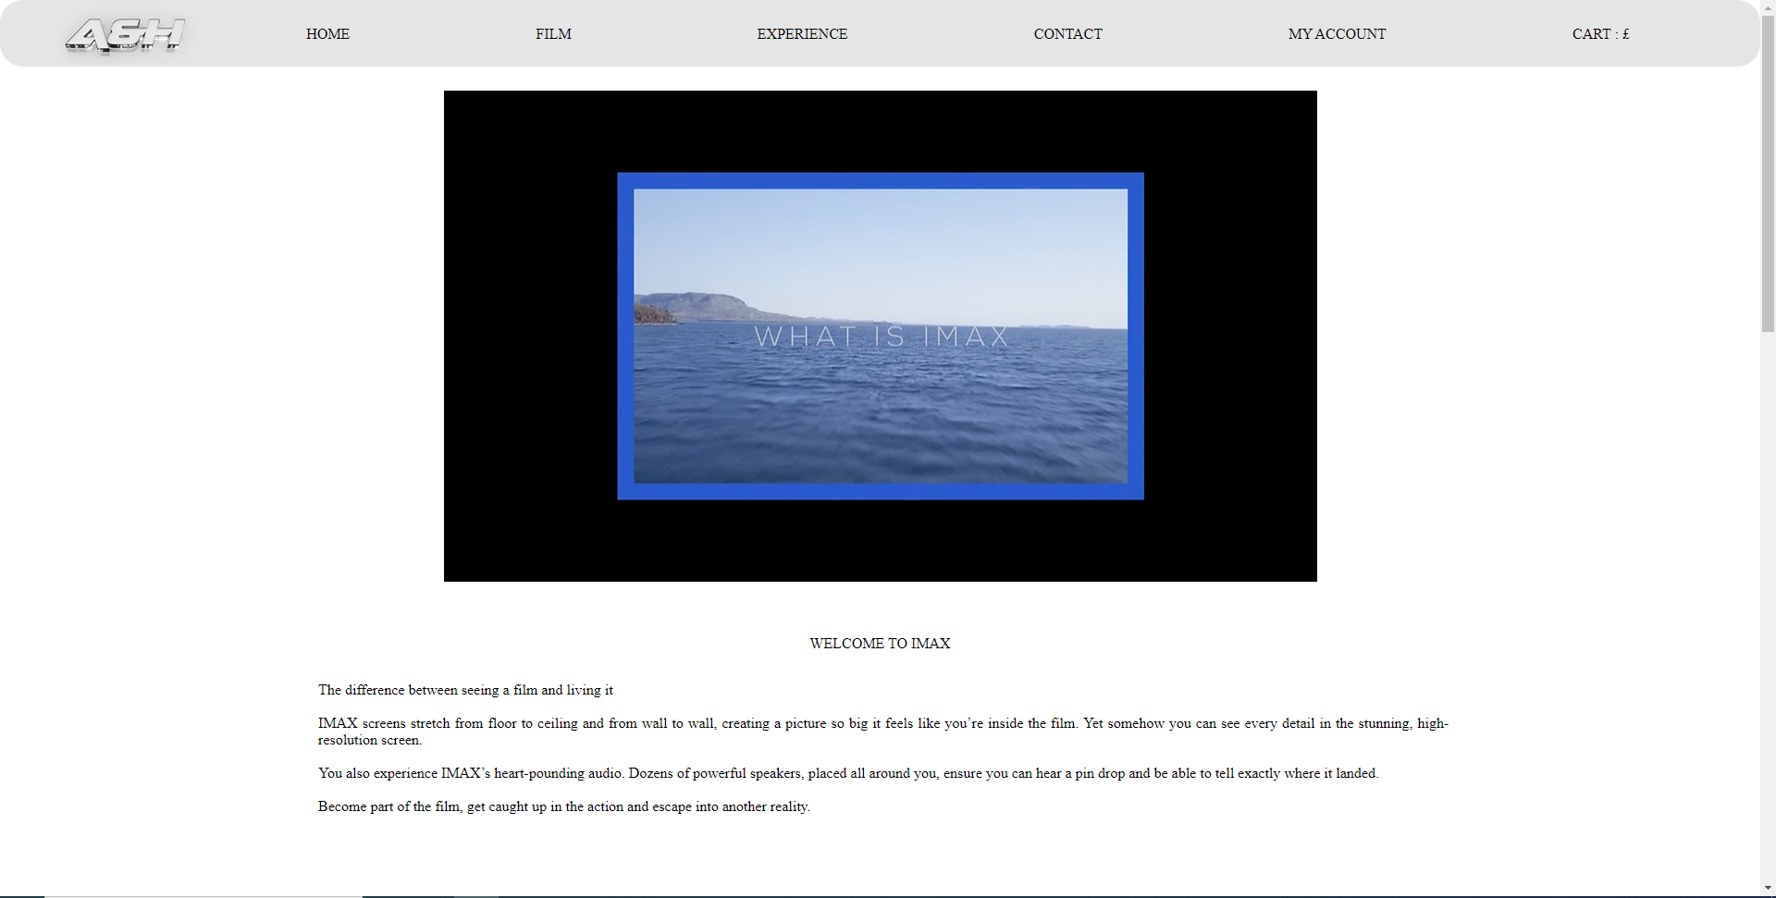

On the "Experience" page, we give all the news in our cinema.

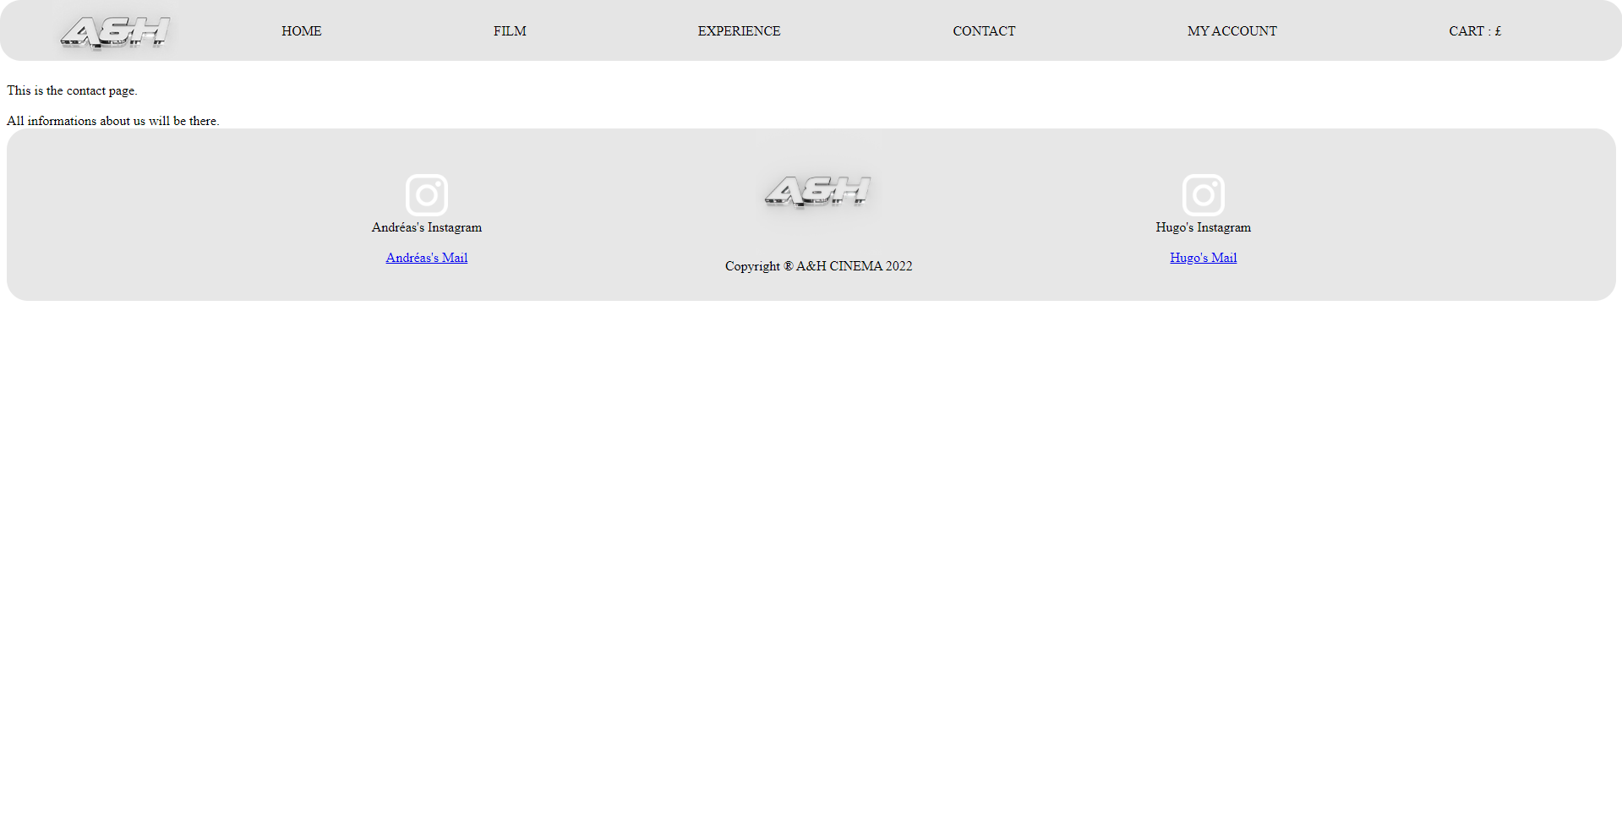

The "Contact" page will contain our personal information of Andréas and Hugo as well as a satisfaction questionnaire for users.

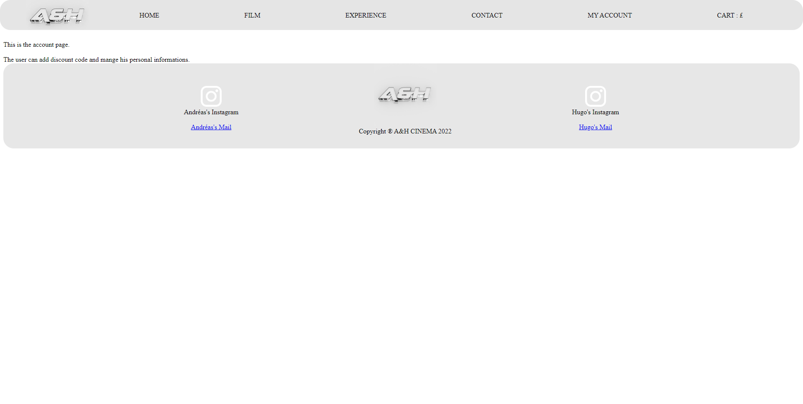

In our "My Account" page, the user will have the possibility to create an account and enter his personal information. They will also be able to see the history of tickets they have already purchased.

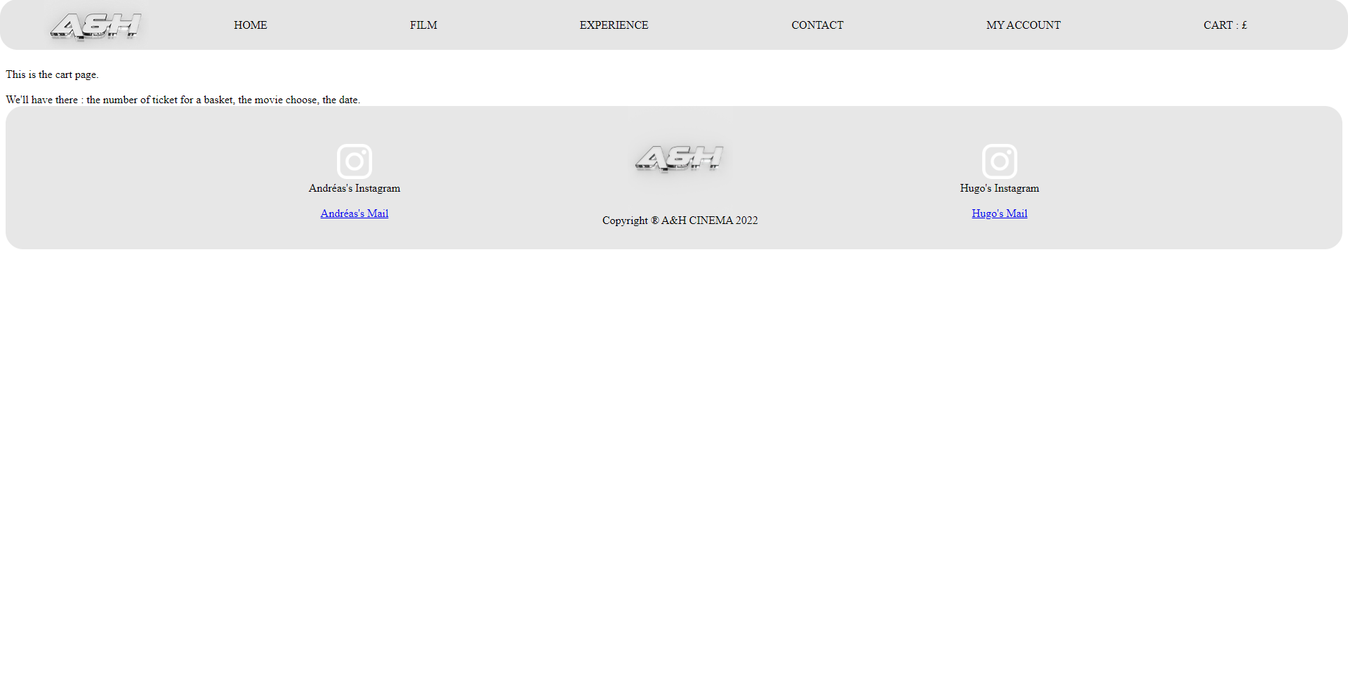

The "Cart" page will contain the user's shopping cart with the tickets they have chosen. The user can then proceed to payment.